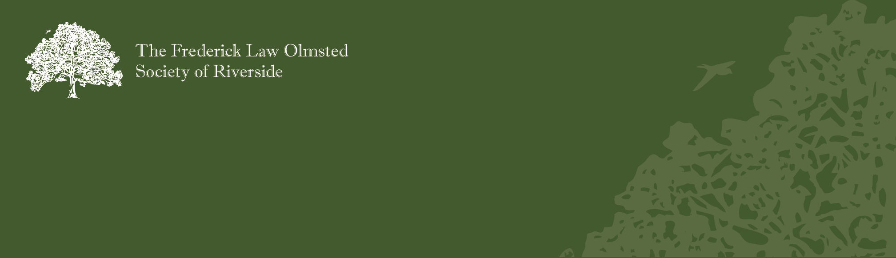Join The Frederick Law Olmsted Society of Riverside as We Tame and Maintain Our Public Areas

2011 Landscape

Workdays Schedule

DATES AND LOCATIONS
• March 26 Longcommon (Big Ball Park)
• April 9 Longcommon (Big Ball Park)
• April 30 Longcommon (Turtle Park)
• May 14 Longcommon (at Addison Rd)
• June 25 Scottswood Common
• July 9 Scottswood Common
• July 30 Scottswood Common
• August 13 Triangle at Scottswood at Millbridge
• September 10 Riverbank (TBA)
• October 1 Riverbank (TBA)
• October 22 Riverbank (TBA)
• November 12 Riverbank (TBA)
Workdays begin at 9am and end at 12pm
Scottswood Common nad Longcommon Common serves as the backbone of Riverside’s landscape architecture. Both were intended to be part of a green space stretching all the way to downtown Chicago. The parks on the riverbank follow the meandering Des Plaines River.
Frederick Law Olmsted designed these parks to provide changing vistas for both pedestrians & vehicles. His plan can be better realized by reducing shrub overgrowth and eliminating weeds. Join us as we tame, and then maintain your public parks of Riverside.
All workdays are scheduled for Saturdays from 9am-12pm. Look for the Riverside Public Works dump truck. Come for an hour or three, whatever your schedule allows. Supervised children are welcome. Service hour credits are available. Bring your favorite work gloves and a water bottle. All other supplies and snacks will be provided.

For questions about the events or to be added to the FLOS Landscape Committee e-list, please contact:
Landscape Committee co-chairs
Holly Machina or Cindy Kellogg
landscape@olmstedsociety.org or 447-0226.

