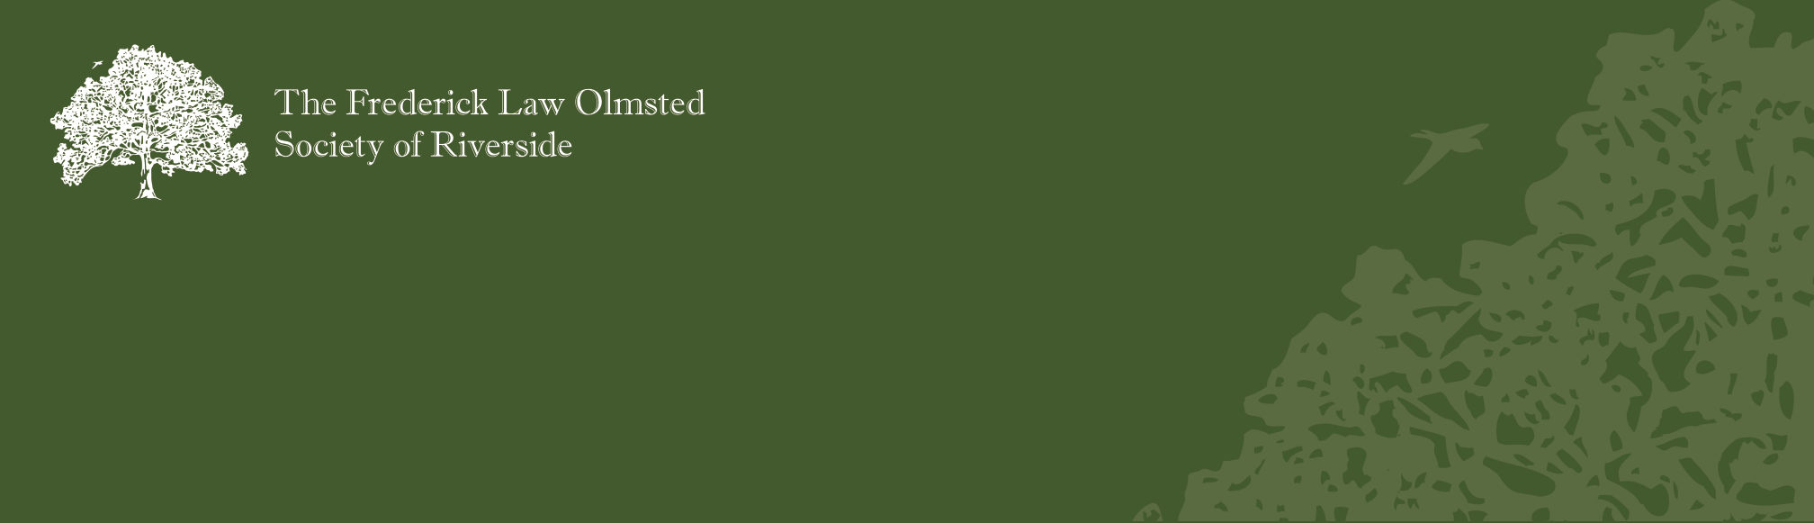Please Join Olmsted Society Member and Master Steward of the Forest Preserve District of Cook County, John Kolar, on a tour of Zoo Woods
Free Tour of Zoo Woods

This area, and Waubansee Preserve, were once owned by the Riverside Improvement Company, and was never fully developed prior to the company’s bankruptcy and the subsequent acquisition by the county for incorporation into the Des Plaines River corridor. Both contain remnants of the pre-settlement flora and fauna of the region and, thanks to the hard work of the Riverside Brookfield High School Ecology Club, the student body in general on Day of Service days, interns from the Morton Arboretum, the Brookfield Zoo, the Natural Gardens and the Peggy Notebaert Nature Museum, are well on their way to full restoration of the richness and diversity of the northern Illinois landscape. Much of the work and many of the tools and resources used came from the Olmsted Society’s generous support of the Ecology Club.
[This tour will take us through the re-emerging prairie and savanna of Zoo Woods and into the recently reclaimed woodlands surrounding the parking lot, much of which is a recovering Oak-Hickory forest typical of the area’s natural woodlands. Here we will see many of the native spring wildflowers indigenous to Riverside and frequently noted in early writings about the Chicago region. These areas were cleared by Audubon interns, funded by the Olmsted Society, this last fall and winter, so we will be among the first visitors seeing these plants in almost a century.]
DATE AND TIMES
Saturday, April 30th Noon – 2pm
** Children’s tour 11:15am – 11:45am**

Directions
Zoo Woods is located just south of 31st Street & just east of 1st Avenue. The parking lot is “U” shaped with two entrances off of 1st Avenue. Please park at the northern end of the parking lot.
Please join us on April 21st for a second tour that will include the prairie and savanna of the Waubansee Preserve. Starting from a buckthorn desert nine years ago, volunteers and interns have produced almost ten acres of extremely high quality prairie and savanna.

For questions about the tours or to be added to the FLOS Landscape Committee e-list, please contact:
Landscape Committee co-chairs
Holly Machina or Cindy Kellogg
landscape@olmstedsociety.org or 447-0226.

