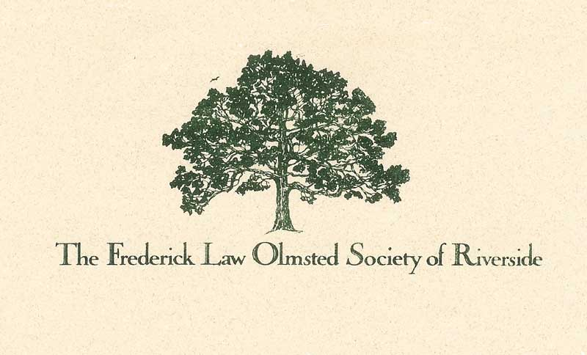
Frederick Law Olmsted Society
Riverside Garden Groomers
Certificate Program 2020

Purpose: To offer garden maintenance information to teens to enrich their understanding of nature, and to offer competencies that may help with securing summer jobs.
Scope: FLOS will provide curated YouTube videos, an online test, and one to two hour(s) of supervised hands-on instruction. During the COVID-19 restrictions, all social distancing and mask guidelines will be followed as well as any other new guidelines from the state or local authorities. FLOS will provide the certificate program only. Students will provide their own tools (a spade, trowel and garden gloves). Any job placement or conduct is the responsibility of the certificate bearer. For teens under the age of 18, parents/guardians will also be asked to sign the waiver and attend the single on-site training session of 1-2 hours.
Approach: Prospective certificate recipients will be recruited through local media (traditional and social), as well as FLOS outreach. Applicants will contact FLOS via email (gardengroomers@olmstedsociety.org) and a syllabus of the program and waiver will be sent. Upon receipt of the waiver, the online test will be sent to the student along with a link to Sign-up Genius to secure a classroom spot with a FLOS Garden Groomer Coach.
Garden Groomer Coaches are FLOS members with deep gardening experience. They will train teens in the coaches’ yards. Teens are trained in small groups to maintain social distancing. Parents/guardians of teens under age 18 will be asked to accompany the teen for the one-two hour training session.
Content: The focus of the garden care program will be natural maintenance. No electronic tools will be used. The topics covered will be:
- Edging garden beds (making a neat edge for aesthetics and maintenance)
- Watering plants (too much, too little, how to tell when a plant needs it)
- Mulching (why, how to mulch around trees, best types)
- Planting annuals and perennials: One-gallon plants or less, how to arrange, depth of planting, etc.
- Weeding: (Note: Homeowner must point out good plants). Correct way to remove weeds manually, how to dispose of weed material.
- Garden safety: Digging cautions, poisonous plants
Certificate Award: Certificates will be mailed or sent electronically after a student has successfully completed the course content. Certificates are good for one year, and can be renewed with the FLOS pending review.
Copyright Frederick Law Olmsted Society 2020

